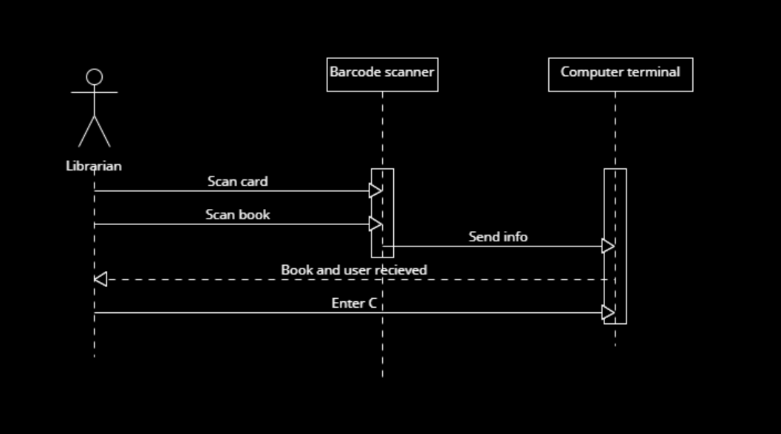

Team 11
Thomas Koska, Soren Lemmon, Will Little, James Zachman

